TD PI CONNECTOR
User Manual

Table of Contents
1. Introduction 2
2. Installation 3
2.1 Prerequisites 3
2.2 Setup Wizard 3
3. Setting up the configuration files 5
3.1 TDPIConnector.Service.exe.config 5
3.2 log4net.config 6
4. PI Point and AF Element modes 7
4.1 PI Point Mode 7
4.1.1 Points.csv (working with PI Points directly) 7
4.1.2 ElementTemplate1.csv (working with AF assets) 7
4.2 AF Element Mode 8
4.2.1 ElementTemplate2.csv (working with AF assets) 8
5. CSV Point Builder 9
6. Backfill 10
6.1 Backfill with TD Backfill 10
6.2 Backfill with TD PI Connector 10
7. Monitoring && Troubleshooting 11
7.1 Monitoring 11
7.2 Logs 12
7.3 Exceptions 12
8. TDengine Support 13

Introduction

The TD PI Connector is a Windows Service that syncs data from the PI System to TDengine. After installing, configuring and starting the TD PI Connector service, the necessary tables will be automatically created in TDengine and the connector will start syncing data from the PI system to TDengine. The TD PI Connector is compatible with TDengine Cloud and a local TDengine cluster hosted on-premise.
Before starting the connector for the first time, you have the option of using the backfill utility to backfill historic data. When the connector starts, it will sync data from the PI system to TDengine, if there is prior data in TDengine either from a backfill or because the connector was running previously, the connector will retrieve the latest row from each table and backfill any missing data. This feature allows for seamless syncing data and should avoid most data gaps.
There are some applications that are installed together with the TD PI Connector:
- CSV Point Builder: a Windows Form application that makes it easy for the user to select the PI Point list for which data is sent to TDengine.
- TDBackfill: a Console Application to backfill old data to TDengine.
The TD PI Connector works using PI Point Mode or AF Element Mode. PI Point mode creates one TDengine table per PI Point/AF Attribute and the AF Element mode creates a table per AF Element.
The following sections of this user manual provide more details about the product.

Installation

2.1 Prerequisites
The prerequisites to install TD PI Connector are below:
- .NET Framework 4.7.2+
- PI AF Client 2018+
- An account to TDengine Cloud or a local install of TD Engine 3.0.1.5+

2.2 Setup Wizard

This will install TD PI Connector as a Windows Service.
2.2.1 Download TDengine.Setup.msi and run it with admin privileges.
2.2.2 The TD PI Connector Wizard will appear.
2.2.3 Click on “Next”.

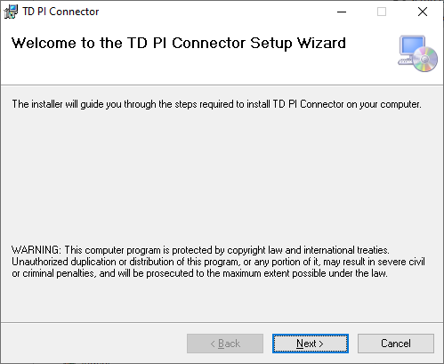
Figure 1 – TD PI Connector Setup Wizard

2.2.4 Select the folder in which the application will be installed. By default, the folder is “C:\Program Files (x86)\TD PI Connector”.
2.2.5 Click on “Next” and click on “Next” again to start copying files.
2.2.6 Click “Close” to close the setup wizard.
2.2.7 Go to the Services management console, click on the TD PI Connector Service and open the TD PI Connector Properties as shown in Figure 2.
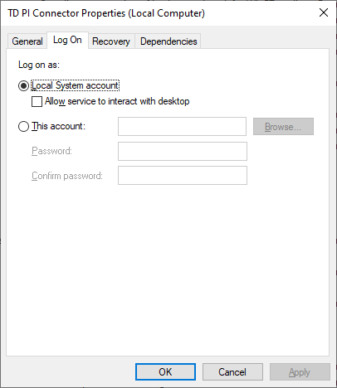
Figure 2 – TD PI Connector Properties
NOTE: The service can run using a local system account or a custom domain account as long as the account has enough privileges to connect and write data to PI Data Archive, PI AF and the TDPIConnector folder.
Do not start the service until the configuration files are configured. Please refer to the next section for more information.

Setting up the configuration files

3.1 TDPIConnector.Service.exe.config
Once TD PI Connector is installed, some configuration files need to be edited.
Open TD PI Connector\TDPIConnector.Service.exe.config file and update the parameter values according to the description below:
PI System Parameters
- UpdateInterval – Number in milliseconds for each cycle to get updated values. Default: 10000.
- PISystemName – AF Server hostname.
- PIServerName – PI Data Archive hostname.
- AFDatabaseName – AF Database name.
- PIDataPipesInstances – Number of PIDataPipes instances for receiving data from PI Data Archive. According to our calculations, one PIDataPipe should handle around 15.000 events per second.
- AFDataPipesInstances – Number of AFDataPipes instances for receiving data from AF Attributes. According to our calculations, one AFDataPipe should handle around 15.000 events per second.

TDengine Parameters - Cloud

- TDengineHost – TDengine Cloud URL (you can find it in Cloud under Data In), for example: “https://gw.us-west-2.aws.cloud.tdengine.com”
- TDenginePort – “443” for TDengine Cloud Port
- TDengineToken – TDengine token (you can find it in Cloud under Data In)
- TDenginePIDatabase – TDengine database name to sync PI data. Default: pi.
- TDEnginePITablesPrefix – String to be added in the beginning of all TDengine tables. Default: (empty).

TDengine Parameters - Local

- TDengineHost – TDengine host, either an IP address or FQDN
- TDenginePort – TDengine port number. Default: “6041”
- TDengineUsername – TDengine username. Default: “root”
- TDenginePassword – TDengine password. Default “taosdata”
- TDenginePIDatabase – TDengine database name to sync PI data. Default: “pi”.
- TDenginePITablesPrefix – String to be added in the beginning of all TDengine tables. Default: (empty).

Automatic Backfill Parameters

- MaxBackfillRangeDays - Maximum number of days to backfill when the service starts up. If this is the first time starting the service, this will determine how many days to backfill data, if data already exists in TDengine, the service will backfill to the last point in TDengine as long as it is within the maximum number of days configed by this parameter. Default: “0” - this means auto backfill is turned off and only new data will be streamed to TDengine.

Monitoring and Troubleshooting Portal Parameters

- WebBaseUrl – Host of the monitoring & troubleshooting portal. Default: http://localhost.
- WebBasePort – Port number of the monitoring & troubleshooting portal. Default: 9000.
- WebMaxPIEvents – Maximum number of events stored by the monitoring & troubleshooting portal to display to the user.
- WebMonitoringEventsEnabled – Enable the web portal to show more detailed information about the events received from PI and sent to TDengine.
- WebMaxTDengineHttpResponses – Maximum number of HTTP responses stored by the monitoring & troubleshooting portal to display to the user.
The monitoring & troubleshooting portal is described later in this user manual.

3.2 Logging
If you want to change the log debug level of the application, Open TD PI Connector\log4net.config file:
<log4net>
<appender name="ColoredConsoleAppender" type="log4net.Appender.ColoredConsoleAppender">
<mapping>
<level value="ERROR" />
...
The default level of logging is “ERROR” to view only error messages. For debugging, you can change the logging level to one of the following levels, defined in order of increasing priority:
- ALL
- INFO
- ERROR
- FATAL

PI Point and AF Element modes

The TD PI Connector works using PI Point Mode or AF Element Mode. PI Point mode creates one TDengine table per PI Point/AF Attribute and the AF Element mode creates a table per AF Element.

4.1 PI Point Mode
The Points.csv and ElementTemplate1.csv files are configured for using the PI Point mode. The workflow of each file is below:

4.1.1 Points.csv (working with PI Points directly)
- When the TD PI Connector starts, it loads the PI Point names from the Points.csv file.
- It creates all the TDengine tables in the TDengine database defined by the TDenginePIDatabase parameter using the PI Point list. One table is created per PI Point.
- It starts to send data from the PI Data Archive to TDengine.
- The CSV Point Builder is a great tool to quickly generate the Point.csv file.

4.1.2 ElementTemplate1.csv (working with AF assets)
- When the TD PI Connector starts, it loads the AF Element Template names from the ElementTemplate1.csv file.
- It searches for all AF element instances derived from each AF Element Template.
- For each AF element found, it gets all their AF Attributes using the PI Point Data Reference.
- It creates a list of PI Points that the AF Attribute is mapping to.
- It creates all the TDengine tables in the TDengine database defined by the TDenginePIDatabase parameter using the PI Point list. One table is created per PI Point/AF Attribute.
- It starts to send data from the PI Data Archive to TDengine.
Both types of CSV files create a TDengine table per PI Point with following columns:
- ts (DATETIME),
- val(NCHAR/INT/FLOAT/DOUBLE/TIMESTAMP)
- quality(INT)
The type of the val column created by the TD PI Connector depends on the PI Point Type. Table 1 shows how the TD PI Connector chooses the TDengine column type of the val column according to point type.

Point Type | TDengine Column Type
Digital | NCHAR
Int16 | SMALLINT
Int32 | INT
Int64 | BIGINT
Float16 | FLOAT
Float32 | FLOAT
Float64 | DOUBLE
String | NCHAR
Timestamp | TIMESTAMP
Table 1 – Mapping between the selected Point Type and the TDengine Column Type

4.2 AF Element Mode
The ElementTemplate2.csv file is configured for using the AF Element mode. According to TDengine, this mode should be used when all the AF Attributes of each AF Element receive data with the same timestamps. The workflow is below:

4.2.1 ElementTemplate2.csv (working with AF assets)
- When the TD PI Connector starts, it loads the AF Element Template names from the ElementTemplate2.csv file.
- It searches for all AF element instances derived from each AF Element Template.
- It creates all the TDengine tables in the TDengine database defined by the TDenginePIDatabase parameter using the AF Element list, one table per AF Element.
- It starts to send data from the PI Data Archive to TDengine.
TD PI Connector creates a TDengine table per AF Element with following columns:
- ts (DATETIME),
- {attribute1_name}_val(NCHAR/INT/FLOAT/DOUBLE/TIMESTAMP)
- {attribute1_name}_status(INT)
- {attribute2_name}_val(NCHAR/INT/FLOAT/DOUBLE/TIMESTAMP)
- {attribute2_name}_status(INT)
- The other attribute columns
Let’s suppose there is an AF Element named “Chicago” and it has two attributes “Pressure” and “Temperature”. The TDengine table for this mode would have the following columns:
- ts (DATETIME),
- pressure_val(FLOAT)
- pressure_status(INT)
- temperature_val(FLOAT)
- temperature_status(INT)
Note that the column type of the TDengine columns ending with “_val” is selected based on the mapping between TDengine data types and the corresponding PI Point Type as shown in Table 1 above.

CSV Point Builder
CSV Point Builder is a Windows Form application that helps the user quickly create/edit the Points.csv file by searching for PI Points on the PI Data Archive.
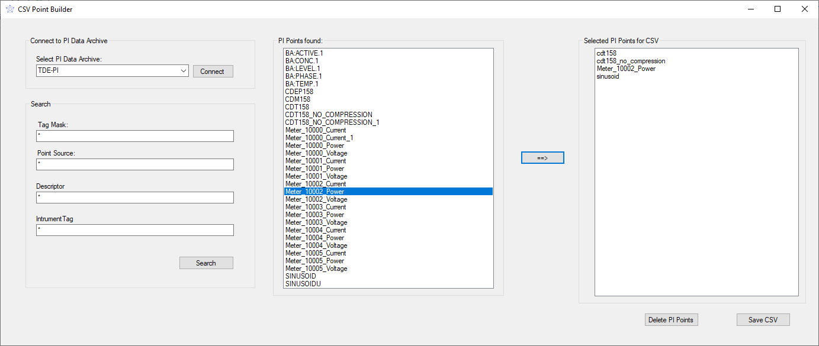
Figure 3 – CSV Point Builder
Steps to use the CSV Point Builder:
- When the application is loaded, the PI Points (stored on the Points.csv file) are shown in the right list box.
- Select the PI Data Archive and click on the “Connect” button.
- Edit the tag mask, point source, descriptor and instrument tag fields to search for PI Points. Click on the “Search” button.
- The list of PI Points found in the search are shown in the left list box of the application.
- Select each PI Point (holding the CTRL button) to add to the CSV file and click on the “== >” button.
- Click on the “Delete PI Points” to delete the selected PI Points (holding the CTRL button) of the right list box.
- Click on the “Save CSV” button to save the CSV file with the selected PI Points.

6. Backfill

6.1 Backfill with TD Backfill
If the user wants to backfill past data to TDengine before sending real-time values, TDBackfill is the tool to achieve this goal. TD Backfill is a console application that is also installed with TD PI Connector.
Before starting to use this tool, the TD PI Connector\TDBackfill.exe.config file needs to be edited using the same key/values of the TDPIConnector.Service.exe.config, described in Section 3.1.
Open the command prompt and type: “TDBackfill –help” to see general usage instructions as shown in Figure 4.
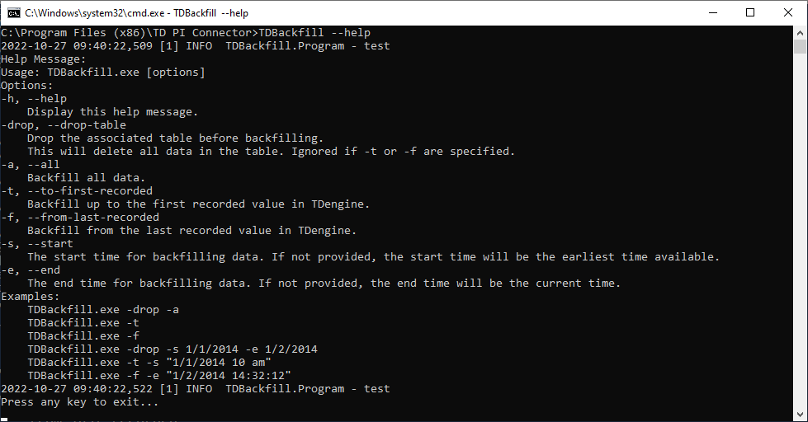
Figure 4 – TDBackfill console application help instructions

6.2 Backfill with TD PI Connector
When the TD PI Connector starts, it retrieves the last row from each table. If the connector detects a data loss within an interval, it will automatically backfill past data. This feature was added to prevent data loss. Note that the TD PI Connector uses backfill data having the most recent value in TDengine table as the starting time of the backfill.
NOTE: If the user wants to migrate older data, TDBackfill is the more appropriate tool.

7. Monitoring && Troubleshooting
The TD PI Connector Service exposes a web portal for monitoring and troubleshooting on the port number specified in the WebBasePort parameter. The portal has 3 main pages:
- Monitoring
- Logs
- Exceptions

7.1 Monitoring
This page provides general information about the items below as shown in Figure 5:
7.1.1 PI Data Archive (Host, port, server version)
7.1.2 TD Engine (Host, port, server version)
7.1.3 PI Data Archive Events
List of events with PI data received by PI Data Archive. If the application is not receiving values for a long time, it probably means that something is not working properly.
7.1.4 TD Engine HTTP status code responses
List of HTTP status code responses of the HTTP requests made by the PI Data Archive against TDengine. If the HTTP status code is not 201, then something is not working properly.

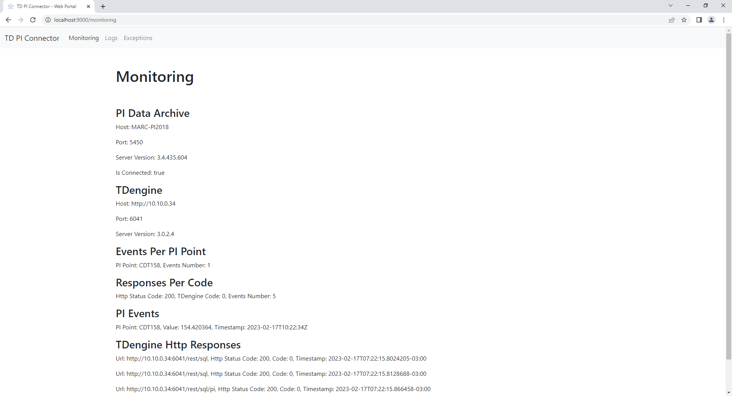
Figure 5 – Monitoring page of the web portal

7.2 Logs
This page allows the users to open the logs of the system (as shown on Figure 6) without having to go to \TDPIConnector\Logs folder.

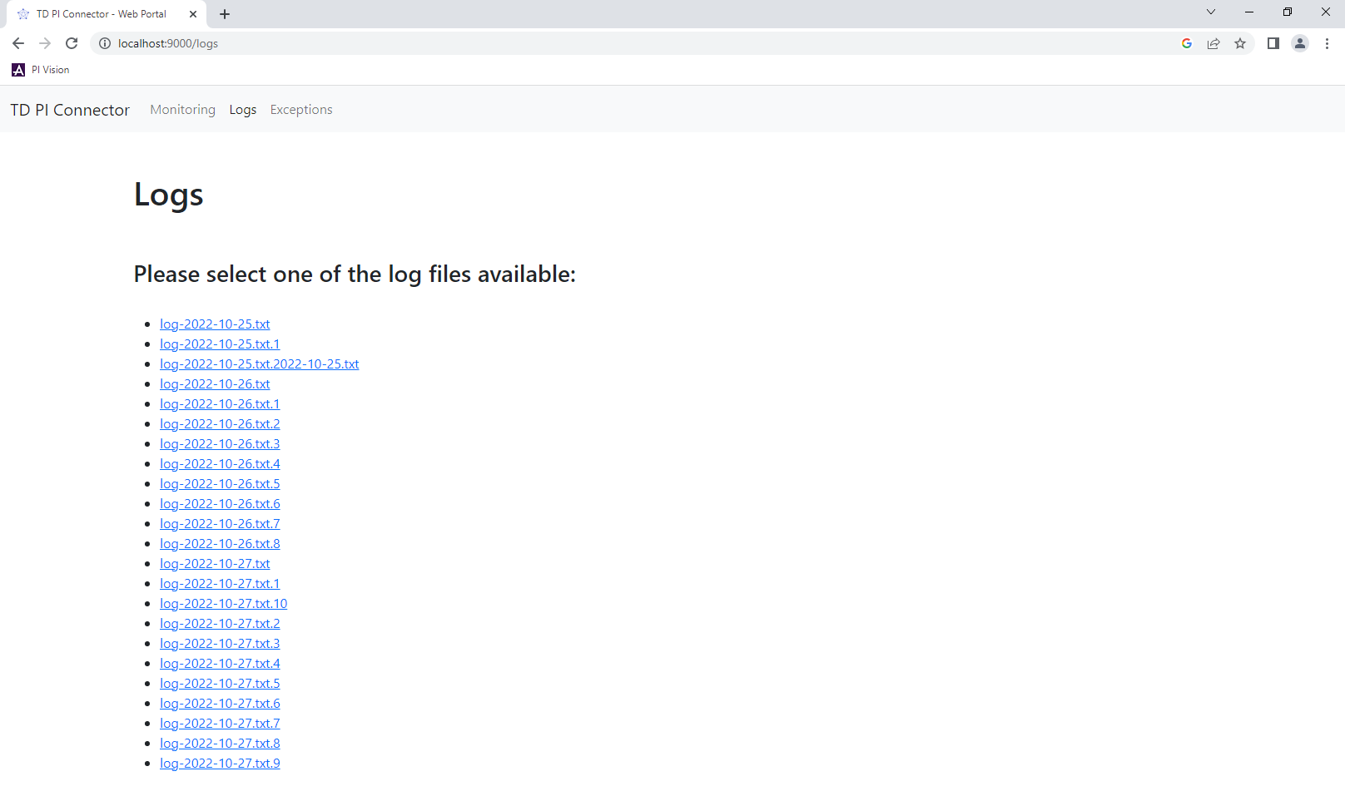
Figure 6 – Logs page of the web portal

7.3 Exceptions
The exceptions page makes it easier for the users to visualize all the exceptions thrown in the application (since the Windows Service has been started) without having to open the logs of the system. The logs contain a lot of information (not only exceptions) so having a page that filters the exceptions could save a lot of the user’s time.

TDengine Support

If you are an Enterprise Edition customer or interested in enterprise services, please contact business@tdengine.com to speak with an account representative.
For more information about TDengine, you can follow us on social media and join our Discord server.

